**Extended Project Proposal**

**CS 2363**

**Dr. Goulden**

**Lince Rumainum and Yunhao Lin**

**Expense Record$**

**Recording day-to-day expenses from groceries, entertainment, and others.**

Preview of the UML of the Expenses parent-child classes:

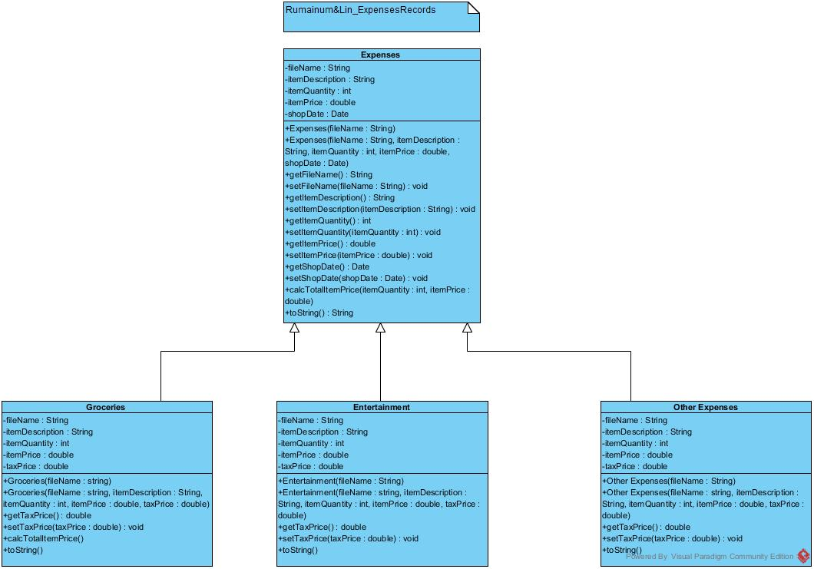

Preview of Expenses.h file:

//Expenses.h

#ifndef EXPENSES_H

#define EXPENSES_H

#include <string>

using namespace std;

class Expenses {

private:

string filename;

string itemDescription;

int itemQuantity;

double itemPrice;

Date shopDate;

public:

Expenses(string filename); // default constractors

Expenses(string filename, string itemDescription, int itemQuantity, double itemPrice, Date shopDate);

string getFilename();

string getItemDescription();

int getItemQuantity();

double getItemPrice();

Date getDate();

void setFilename(string filename);

void setItemDescription(string itemDescription);

void setItemQuantity(int itemQuantity);

void setItemPrice(double itemPrice);

double calcTotalItemPrice(int itemQuantity, double itemPrice);

string toString(); // output

};

#endif

Preview of Expenses.cpp file:

// Expenses.cpp

/*

http://www.tutorialspoint.com/cplusplus/cpp_date_time.htm

http://stackoverflow.com/questions/23418390/how-to-convert-a-c-string-to-uppercase

*/

#include <iostream>

#include <ctime>

#include <string>

#include <sstream>

#include <cctype>

#include "Date.h"

#include "Expenses.h"

using namespace std;

// default constractors

Expenses::Expenses(string filename) {

this->filename = filename;

}

Expenses::Expenses(string filename, string itemDescription, int itemQuantity, double itemPrice, Date shopDate) {

this->filename = filename;

this->itemDescription = itemDescription;

this->itemQuantity = itemQuantity;

this->itemPrice = itemPrice;

this->shopDate = Date();

}

string Expenses::getFilename() {

return filename;

}

string Expenses::getItemDescription() {

return itemDescription;

}

int Expenses::getItemQuantity() {

return itemQuantity;

}

double Expenses::getItemPrice() {

return itemPrice;

}

Date Expenses::getDate() {

return shopDate;

}

void Expenses::setFilename(string filename) {

this->filename = filename;

}

void Expenses::setItemDescription(string itemDescription) {

this->itemDescription = itemDescription;

}

void Expenses::setItemQuantity(int itemQuantity) {

this->itemQuantity = itemQuantity;

}

void Expenses::setItemPrice(double itemPrice) {

this->itemPrice = itemPrice;

}

double Expenses::calcTotalItemPrice(int itemQuantity, double itemPrice) {

return itemQuantity*itemPrice;

}

// output

string Expenses::toString() {

return itemDescription + " " + to_string(itemQuantity) + " $" + to_string(calcTotalItemPrice(itemQuantity, itemPrice));

}